**Topic: T-Rex Chrome Dino Game**



**PROBLEM STATEMENT:**

The project aims to build a Turing machine and Push Down Automata (PDA) for the T-Rex Chrome Dino Game. The result depends on the Golden Food the Dino eats or the number of Crows or Trees it hits.

**Preface and Analysis of problem statement:**

Initially the Dino is given 5 lives. It should complete within the lives remaining. On the way, it will be taking in the Food available in the path. It will come across some special foods such as a number of Golden Stones (GS) and a single Golden Food (GF). If it gets the GF, the player wins. The power of the GS is that it gains an extra life. If the Dino hits any Tree (T) or Crow (C) it loses a life. They both are the enemies in the game. In its journey the Dino will be able to Jump (D) and Crouch (U) to escape from its enemies. The ultimate path of the game is to make the Dino reach the GF with at least one life remaining.

**Alphabet Set (∑):**

1. Life
2. D = Down
3. U = Up
4. GS = Golden Stone
5. F = Food
6. GF = Golden Food
7. T = Tree
8. C = Crow

**Language (L):**

L = ( D + U ) . ({ D, U, GS, F, GF, T, C }*.GF. { D, U, GS, F, GF, T, C }*)

**Examples:**

L = { DGF }, { UGSFCTTCGF }, { DTFFGSGSGSTDUDU }, { DUDF }……

**PDA – PushDown Automata:**

**A Brief intro of theory:**

Context Free Language is visualized in Push Down Automata (PDA). PDA. It comes with an extra stack memory. This extends the capabilities of the Finite Automata.

PDA comes with **Seven Tuples** (Q, ∑, Γ, δ, q0, z, F):

Q = Finite set of States

∑ = Finite set of Input Symbols

Γ = Finite Stack Alphabets

δ = Transition function

q0 = Initial State

z = Initial Stack Symbol

F = Set of Final States

**Implementation in PDA:**

The stack of the PDA is used to store and remember the count of lives available for the player. Initially the stack gets loaded with 5 lives then its manipulated according to the elements that it passes/ consumes/ hits. If it consumes the Golden Stone, a bonus life is pushed on to the stack. If it hits one of the enemies (trees/ crows), a life is popped out of the stack. If the stack runs out of the lives, then the Dino dies.

**Q:**

1. q0 – Initial State / Life State1
2. q1 – Life State2
3. q2 – Life State3
4. q3 – Life State4
5. q4 – Life State5
6. q5 – Play State
7. q6 – Movement State
8. q7 – Eat Sate
9. q9 – Gold Stone State
10. q10 – Enemy State
11. q11 – Trap State
12. q8 – Final State

**∑:**

1. Life
2. D = Down
3. U = Up
4. GS = Golden Stone
5. F = Food
6. GF = Golden Food
7. T = Tree
8. C = Crow

**Γ:**

Life

Z – Default stack symbol

**q0:**

1. q0 = Initial Life State

**F:**

1. q8 – Final State

**z:**

1. z = Initial Stack element

**δ (Transition Function):**

|  |  |  |  |  |
| --- | --- | --- | --- | --- |
| STATE | INPUT | PREVIOUS STACK | NEXT STATE | NEW STACK |
| q 0 | λ | z | q 1 | z, life |
| q 1 | λ | z, life | q 2 | z, life, life |
| q 2 | λ | z, life, life | q 3 | z, life, life, life |
| q 3 | λ | z, life, life, life | q 4 | z, life, life, life, life |
| q 4 | λ | z, life, life, life, life | q 5 | z, life, life, life, life, life |
| q 5 | D | z, life, life, life, life, life | q 6 | z, life, life, life, life, life |
| q 5 | U | z, life, life, life, life, life | q 6 | z, life, life, life, life, life |
| q 6 | U | z, life, life, life, life, life | q 6 | z, life, life, life, life, life |
| q 6 | D | z, life, life, life, life, life | q 6 | z, life, life, life, life, life |
| q 6 | F | z, life, life, life, life, life | q 7 | z, life, life, life, life, life |
| q 6 | GF | z, life, life, life, life, life | q 8 | z, life, life, life, life, life |
| q 6 | T | z, life, life, life, life, life | q 10 | z, life, life, life, life |
| q 6 | C | z, life, life, life, life, life | q 10 | z, life, life, life, life |
| q 6 | GS | z, life, life, life, life, life | q 9 | z, life, life, life, life, life, life |
| q 7 | U | z, life, life, life, life, life | q 6 | z, life, life, life, life, life |
| q 7 | D | z, life, life, life, life, life | q 6 | z, life, life, life, life, life |
| q 7 | T | z, life, life, life, life, life | q 10 | z, life, life, life, life |
| q 7 | C | z, life, life, life, life, life | q 10 | z, life, life, life, life, |
| q 7 | GS | z, life, life, life, life, life | q 9 | z, life, life, life, life, life, life |
| q 7 | GF | z, life, life, life, life, life | q 8 | z, life, life, life, life, life, |
| q 9 | F | z, life, life, life, life, life | q 7 | z, life, life, life, life, life |
| q 9 | C | z, life, life, life, life, life | q 10 | z, life, life, life, life |
| q 9 | T | z, life, life, life, life, life | q 10 | z, life, life, life, life |
| q 9 | GS | z, life, life, life, life, life | q 9 | z, life, life, life, life, life, life |
| q 9 | GF | z, life, life, life, life, life | q 8 | z, life, life, life, life, life |
| q 9 | U | z, life, life, life, life, life | q 6 | z, life, life, life, life, life |
| q 9 | D | z, life, life, life, life, life | q 6 | z, life, life, life, life, life |
| q 10 | GS | z, life, life, life, life, life | q 9 | z, life, life, life, life, life, life |
| q 10 | C | z, life, life, life, life, life | q 10 | z, life, life, life, life |
| q 10 | T | z, life, life, life, life, life | q 10 | z, life, life, life, life |
| q 10 | F | z, life, life, life, life, life | q 7 | z, life, life, life, life, life |
| q 10 | U | z, life, life, life, life, life | q 6 | z, life, life, life, life, life |
| q 10 | D | z, life, life, life, life, life | q 6 | z, life, life, life, life, life |
| q 10 | GF | z, life, life, life, life, life | q 8 | z, life, life, life, life, life |
| q 10 | λ | Z | q 11 | [] |

**JFLAP Model:**

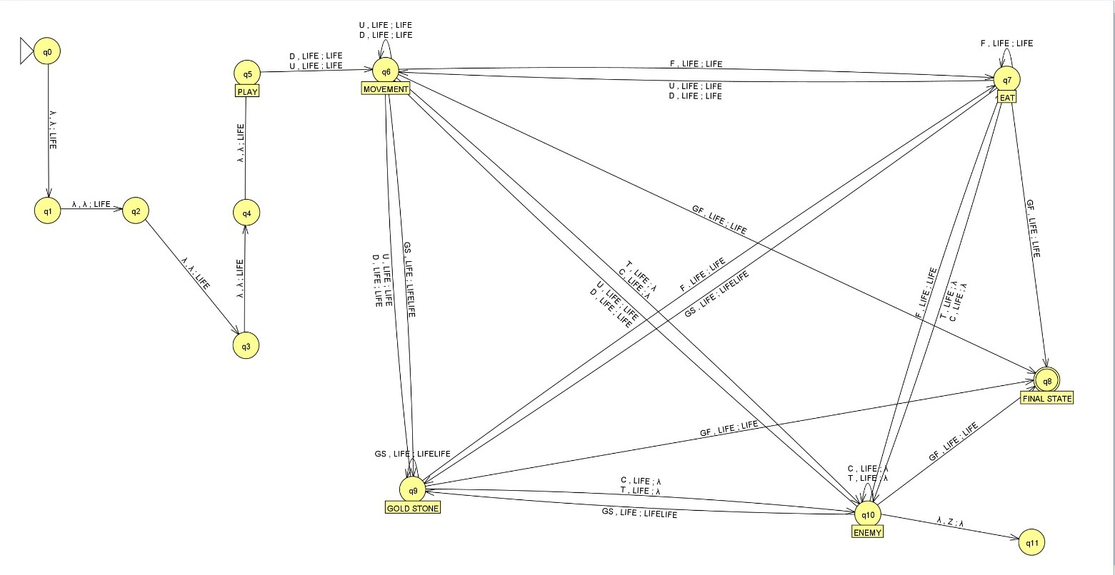

**Anomalous Behaviour:**

* **The game stops right when the no of lives of Trex is zero.**
* **The no of live T rex can get by Gold Stone is infinity.**
* **After encountering food , it is considered consumed.**
* **This Equation (GS+5)-E>=1 must remain true for the game to run.**

**Output:**

1. The Dino wins the Game! Yayyy! 😊

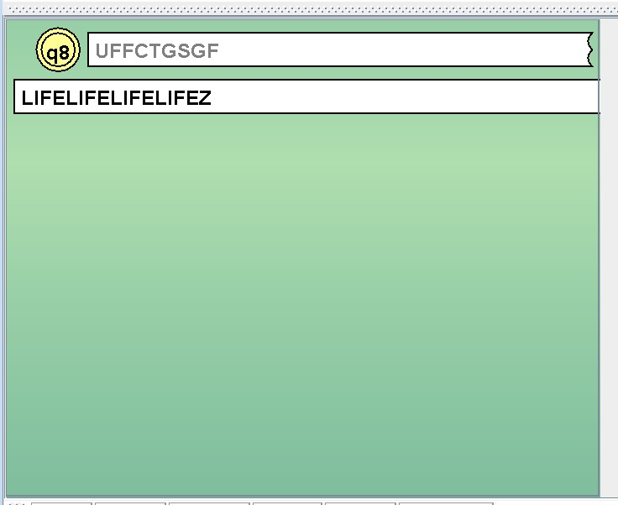

2. The Dino run out of lives! ☹

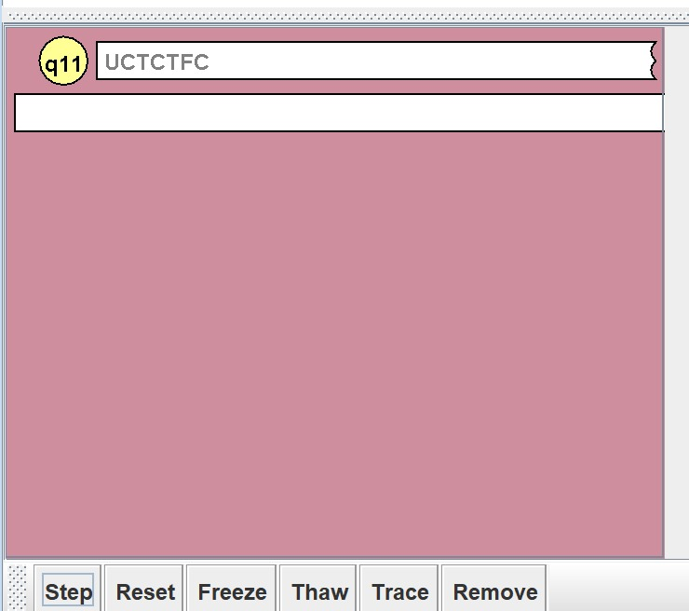

3. The Dino follows a valid input path! 😐

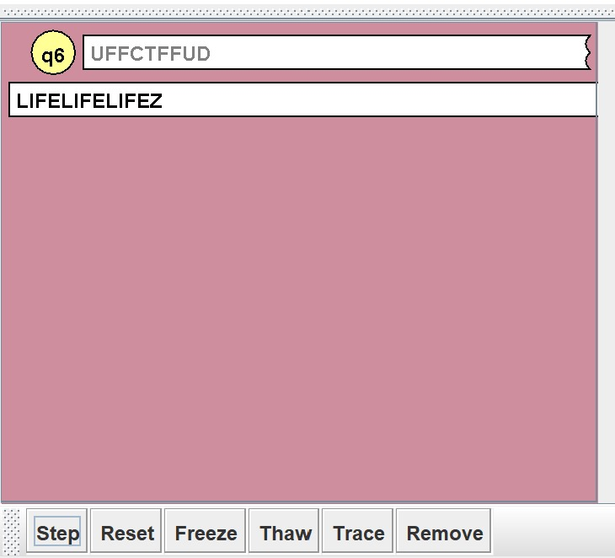

**Turing Machine:**

**A Brief intro of theory:**

A Turing Machine is an infinitely long tape of symbols that can be read, written on, and erased. There are squares on the tape. The Turing machine can only read one symbol at a time and decides what to do next depending on its present state and the symbol it is reading using a set of rules (the transition function). The Finite control has a Read/write head, which points to a cell in tape.

Turing Machine comes with **Seven Tuples** (Q, X, ∑, δ, q0, B, F):

Q = All States in the Turing Machine

X = Tape

∑ = Finite set of Input Symbols

δ = Transition function

q0 = Initial State

B = Blank Symbol

F = Set of Final States

**Implementation in Turing Machine:**

We store the given input in the tape of the Turing Machine’s tape along with a starting symbol just to differentiate the input with the upcoming manipulations. Once the machine starts, the header goes to the left of W and rewrites the 5 blank spaces to initial lives of the Dino. Then it returns to the start of the input. If D/U is provided, then we just keep the symbol as it is and move right. If F is given it is changed to x and moves to the rest of the string. If S is given in the movement state, then it changes to x and it moves left and adds another L and returns back. If T/C is encountered, then it changes to x and moves left to take one life of Dino. From the food state if we get G, then moves right and the game ends there and the Dino wins!

**Q:**

1. q0 – Initial State

2. q1 – Initial Life State

3. q2 – Initial Life State

4. q3 – Initial Life State

5. q4 – Initial Life State

6. q5 – Initial Life State

7. q6 – Initial Life State

8. q7 – Initial Life State

9. q8 – Movement State

10. q9 – Enemy State

11. q10 – Intermediate State

12. q11 – Intermediate State

13. q12 – Trap State

14. q13 – Stone State

15. q14 – Food State

16. q16 – Intermediate State

17. q15 – Final State

**X:**

We have used single tape Turing machine as per our required problem.

**∑:**

1. Life

2. D = Down

3. U = Up

4. W = Differentiate I/O

5. F = Food

6. S = Stone

7. T = Tree

8. C = Crow

9. x = Rewrite

10. G = Golden Food

**δ (Transition Function):**

|  |  |  |  |  |
| --- | --- | --- | --- | --- |
| STATE | CURRENT SYMBOL | NEXT STATE | WRITTEN SYMBOL | MOVE DIRECTION |
| q 0 | W | q 1 | W | L |
| q 1 | # | q 2 | L | L |
| q 2 | # | q 3 | L | L |
| q 3 | # | q 4 | L | L |
| q 4 | # | q 5 | L | L |
| q 5 | # | q 6 | L | L |
| q 6 | # | q 7 | # | R |
| q 7 | L | q 5 | L | R |
| q 5 | L | q 4 | L | R |
| q 4 | L | q 3 | L | R |
| q 3 | L | q 2 | L | R |
| q 2 | L | q 1 | L | R |
| q 1 | U | q 8 | U | R |
| q 1 | W | q 8 | U | R |
| q 1 | D | q 8 | U | R |
| q 8 | D | q 8 | D | R |
| q 8 | U | q 8 | U | R |
| q 8 | W | q 8 | W | R |
| q 8 | x | q 8 | X | R |
| q 8 | T | q 9 | X | L |
| q 8 | C | q 9 | x | L |
| q 8 | # | q 12 | # | R |
| q 8 | S | q 13 | X | L |
| q 8 | G | q 15 | G | R |
| q 8 | F | q 14 | X | R |
| q 9 | D | q 9 | D | L |
| q 9 | S | q 9 | S | L |
| q 9 | U | q 9 | U | L |
| q 9 | W | q 9 | W | L |
| q 9 | X | q 9 | x | L |
| q 9 | F | q 9 | F | L |
| q 9 | L | q 10 | x | L |
| q 9 | T | q 14 | x | L |
| q 9 | C | q 14 | x | L |
| q 10 | F | q 14 | x | R |
| q 10 | L | q 11 | L | R |
| q 10 | x | q 11 | x | R |
| q 11 | U | q 8 | U | R |
| q 11 | D | q 8 | D | R |
| q 11 | X | q 8 | x | R |
| q 11 | W | q 8 | W | R |
| q 11 | S | q 8 | S | R |
| q 11 | F | q 14 | x | R |
| q 14 | F | q 14 | x | R |
| q 14 | x | q 14 | x | R |
| q 14 | W | q 14 | W | R |
| q 14 | U | q 14 | U | R |
| q 14 | D | q 14 | D | R |
| q 14 | # | q 12 | # | L |
| q 14 | G | q 15 | G | R |
| q 14 | S | q 13 | x | L |
| q 13 | F | q 13 | F | L |
| q 13 | x | q 13 | x | L |
| q 13 | W | q 13 | W | L |
| q 13 | S | q 13 | S | L |
| q 13 | L | q 13 | L | L |
| q 13 | D | q 13 | D | L |
| q 13 | U | q 13 | U | L |
| q 13 | # | q 16 | L | R |
| q 16 | L | q 16 | L | R |
| q 16 | S | q 8 | S | R |
| q 16 | W | q 8 | W | R |
| q 16 | X | q 8 | x | R |
| q 16 | D | q 8 | D | R |
| q 16 | U | q 8 | U | R |

**JFLAP Model:**

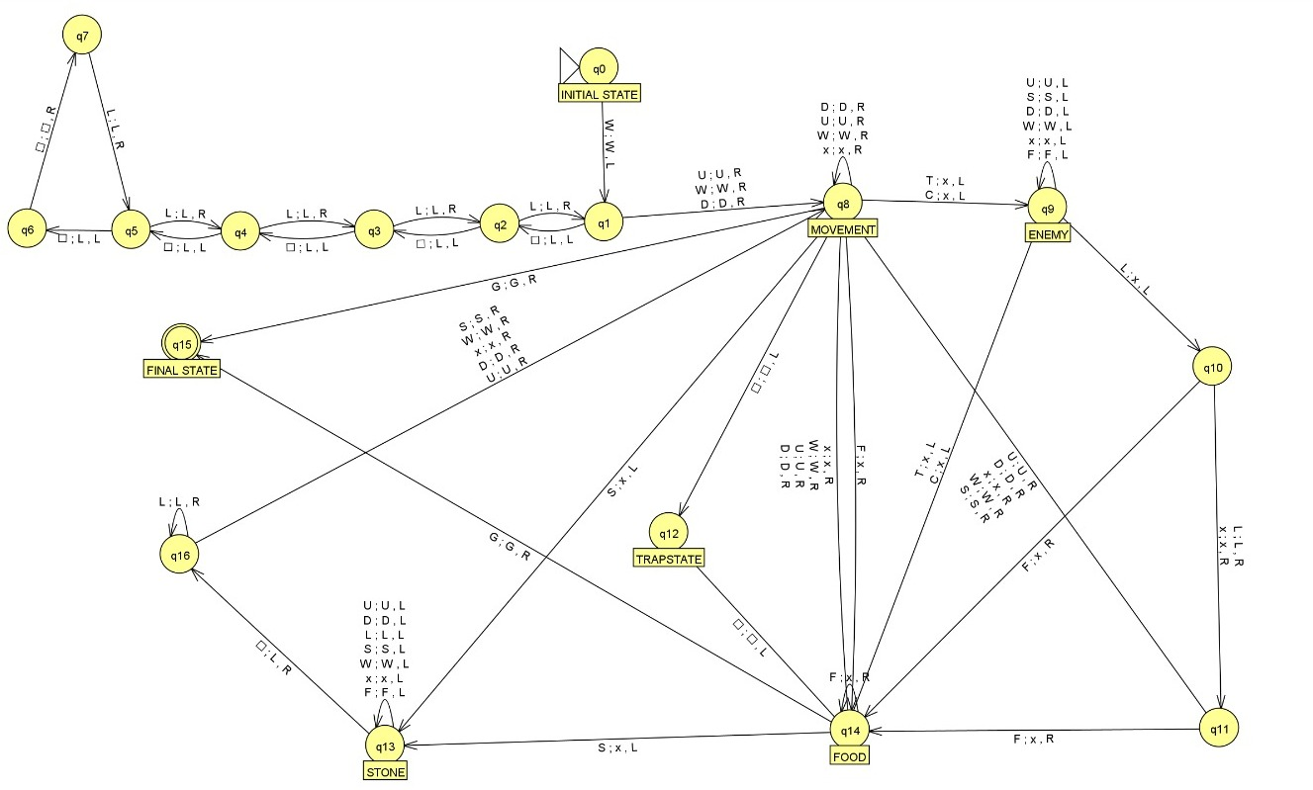

**Output:**

1. The Dino wins the Game! Yayyy! 😊

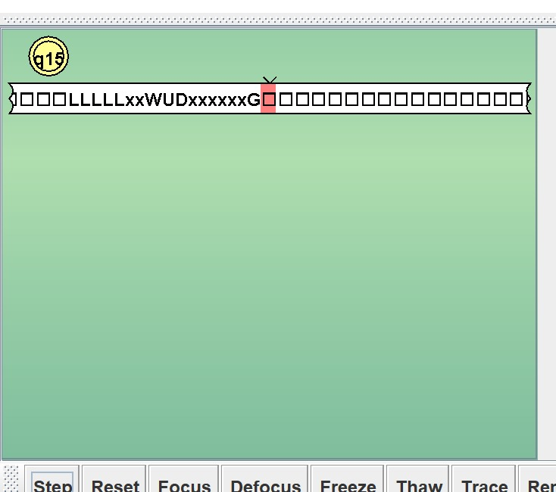

2. The Dino run out of lives! ☹

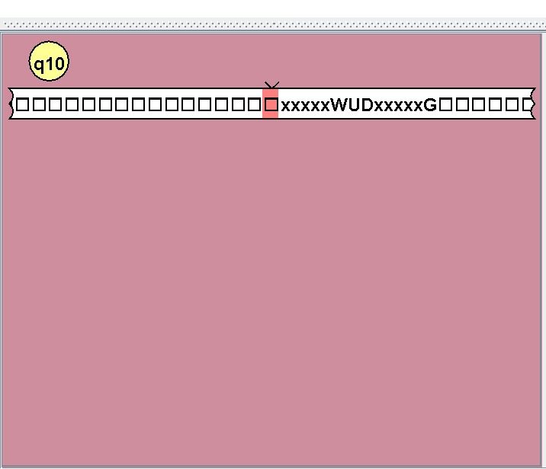

3. The Dino follows a valid input path! 😐

